Math 165 Pre-Calculus
Kye words: conversions between radian and degree measure – arc length of a sector – sector area application word problems
Applicable courses: Pre-calculus, Applied College Algebra and Trigonometry (where measurement conversions from one unit to another are required)
Global objective: applying discipline content in a global or international context.

Amsterdam Map 1: Scale: 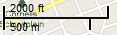
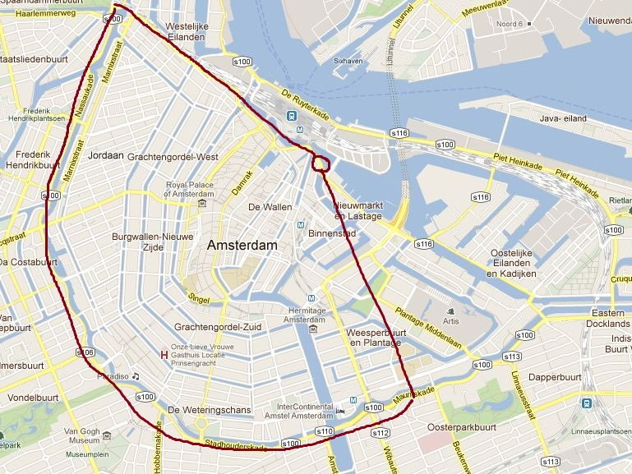
Motivation:
Suppose your studies take you to Europe and for a few leisure days to exciting Amsterdam. On your flight you read in the airline magazine that most of the tourist attractions, museums, restaurants, and bars are in the red colored sector of the “Amsterdam Half-moon” shown on the left.

- If the radius of the sector is 7cm, find its actual distance in meters and miles. Round each answer to a whole number. Familiarize yourself with the scale of the map to be able to do this computation.

- How big of an area in square miles do you expect to explore on your sightseeing trip given the fact that you stay within the sector of a central angle of Ɵ = 150°? Round your answer to one decimal place.

In your English Literature course, you have read Anne Frank’s Diary, which has been reproduced in 51 languages. Now you have the opportunity to learn about Anne’s inspiring story and visit her hiding place at the Anne Frank House (AFH), a well-known landmark in the city. Of course, you head off to the site in the true Dutch way with a rental bike.

Find two math-related characteristics about the Dutch people that reflect on their favorite mode of transportation, biking. Check the college library and online resources for information and provide all sources and websites used. (No credit will be given without proper documentation). Is there a “bicycle culture” in the Netherlands? Write down your thoughts in five complete sentences explaining what speaks for or against that statement.
- Refer to Amsterdam Map 2 below to follow the arrows of your bike path from your lunch place to the Anne Frank House (AFH).
Amsterdam Map 2:________________________________________ Scale:
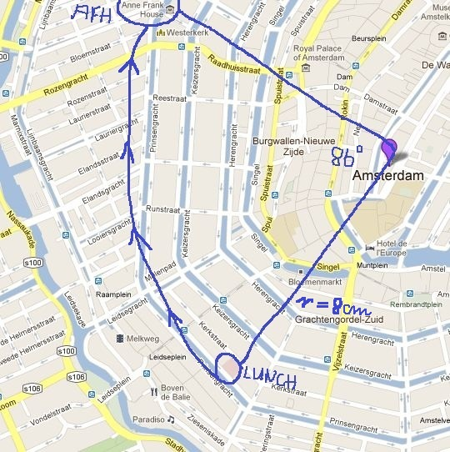
Considering that both the scale and the central angle have now changed, find the following:

- The new radius in meters as a whole number.

- The length of the arc in both meters and miles that you must travel to get from your lunch place to AFH. Round your final answers to one decimal place.

- How well does the arc length approximate the actual bike path along the canals on the paved road? Explain.

Considering that both the scale and the central angle have now changed, find the following:

- The new radius in meters as a whole number

- The length of the arc in both meters and miles that you must travel to get from your lunch place to AFH? Round your final answers to one decimal place.

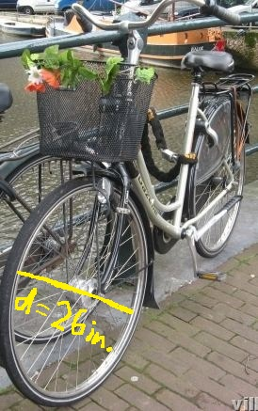
I normally end the project with the following question:
e) Now let’s take a close look at the bike to the left with a wheel diameter of 26inches. What is the angle in both radians and degrees that the wheel turns when the bicycle turns 15 ft? Round your numerical answer to one decimal place.

Resources:
http://www.planetware.com/amsterdam/house-of-anne-frank-nl-nh-anne.htm
http://www.nationsonline.org/oneworld/m ap/google_map_Amsterdam.htm (satellite view)
http://www.ski-epic.com/amsterdam_bicycles/

