Math 153/B. Leitherer Grouped Mean
CCBC - Essex

Did the mean age of Marylanders with positive COVID-19 tests change from March 2020 to July 2021?

Scenario I:
On April 2nd, 2020, the Maryland COVID-19 Data Dashboard posted the following graphic online: a histogram of the age distribution of MD residents confirmed with COVID0-19.
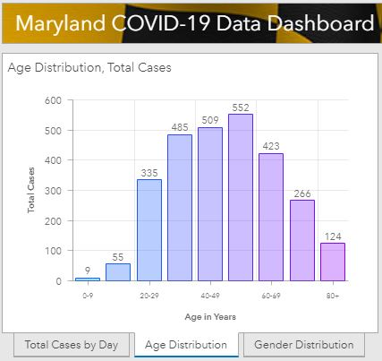

Resource: https://coronavirus.maryland.gov/

- How many confirmed COVID-19 cases did Maryland have on April 2nd, 2020?
- What is the width of the histogram?
- What shape does the data appear to have?
- Provide an estimate for the most typical age of Marylanders infected with COVID-19 on April 2nd, 2020. What do you expect the mean age to be?
- Create a frequency distribution and find the average age manually. Use the formula for the mean for grouped data. [Hint: treat the class of 80+ year old as 80 – 89.]
- How close is your estimate to the computed mean age?

Scenario II:
About a year and 3 months later, on July 18, 2021, the Maryland COVID-19 Data Dashboard provided the following frequency table of MD residents confirmed with COVID0-19 by age groups:

Dashboard Table as of July 18, 2021:

Age Classes | Cases
0 – 9 | 26343
10 – 19 | 47957
20 – 29 | 85151
30 – 39 | 79554
40 – 49 | 69084
50 – 59 | 68973
60 – 69 | 45940
70 – 79 | 25213
80 + | 15982

- Transfer the frequency table into StatCrunch. Remember to replace the 80+ class by 80 – 89.

- Use StatCrunch to find the mean age of Marylanders confirmed with COVID-19 as of July 18, 2021. If you do not know how to calculate the mean from grouped data, refer to the course materials or the StatCrunch Guide for help with using the appropriate technology.

- What is the new mean age of Marylanders confirmed with COVID-19 in July 2021? Does it appear that it has changed from March 2020 to July 2021? Consider supporting your work with frequency and relative frequency distributions. Then compare the distributions and explain how data has shifted. Write 6-8 well-written sentences to discuss your findings.

Scenario III: In this part I have added a global perspective to the analysis. Graph 1 depicts Maryland data from the July 18 Table (see above) and Graph 2 visualizes Covid-19 infections by age and gender in Bavaria, a state in Germany (end of July 21).

Analyze the two graphs given below. What story do those graphs tell? In what aspects are the graphs similar, in what aspects different? Explain in 8-10 well-written sentences.

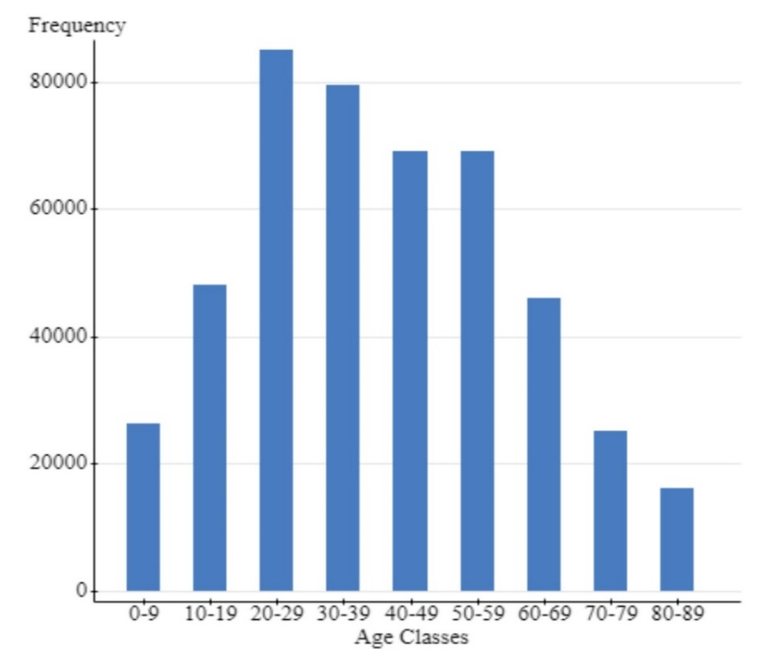21
Graph 1:
Covid-19 confirmed Infections by Age in the State of Maryland, USA, July 18, 2021
https://coronavirus.maryland.gov/

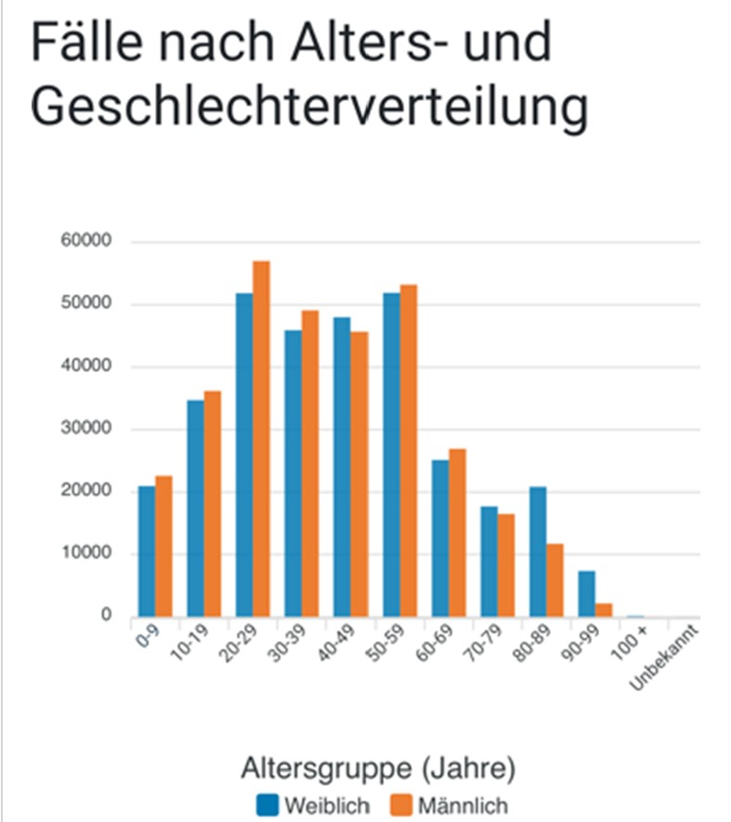
Graph 2:
Covid-19 confirmed Infections by Age and Gender in the State of Bavaria, Germany, end of July 2021
Blue = females
Orange = males

https://lgl.bayern.de/

